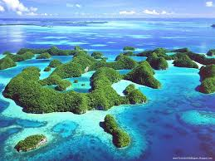**Palau Reefs**

Palau's reefs boast breathtaking biodiversity, with vibrant coral formations and diverse marine life, making them a UNESCO World Heritage site.

**History**

Palau's reefs boast a rich history, serving as vital ecosystems and witnessing the resilience of marine biodiversity amid various environmental challenges.